**C. Moreno-6 day Student Instructional Materials-Grade 3 Math/Science**

Each day students are to follow the following schedule!

Daily Sprint! <https://www.engageny.org/resource/released-2019-3-8-ela-and-mathematics-state-test-questions>

Time yourself: 1 Minute-see how many multiplication facts you can answer in 1 minute! Once you are done, check your work. Give yourself a check for the right answers-correct the wrong ones. Tally your correct answers. By the end of the week, did you get better? I hope so!

***Day One***: Complete the application and exit for lesson 1 pgs 131 and 135. Use problem set 1 to help you. Do your next multiplication fact 3 times each.

***Day Two***: Complete the application and exit for lesson 2 pgs 137 and 141. Create index cards and have someone challenge you to see how many you know in under a minute.

***Day Three***: Complete the application and exit for lesson 3 pgs 143 and 147. Use problem set 3 to help you. Create 2 word problems using your multiplication facts on a piece of loose-leaf. Remember to use our word problem rubric.

***Day Four:*** Complete the application and exit for lesson 3 pgs 153 and 157. Use problem set 4 to help you. Complete Session One of the NYS Math Practice 2019 test. There are 11 multiple choice questions. Remember to use your test taking strategies. (See Attached practice test)

***Day Five:*** Complete the application and exit for lesson 4 pgs 159 and 163. Use problem set 5 to help you. Complete the multiple choice questions on session two of the NYS Math Practice 2019 test. There are 8 questions. Remember to use your test taking strategies. See attached practice test)

***Day Six***: Complete the application and exit for lesson 6 pgs 165 and 169. Use problem set 6 to help you. Complete the short response questions on session two of the NYS Math Practice 2019 test. There are 7 questions. Be detailed. Use the RDW process and CUBES. (See attached practice test)

***Science:*** Using your knowledge on Bridges: Research one type of bridge and write a summary about the history of that bridge: Who created the bridge, why it was created, when and where it was created and what type of bridge it is. Use the EDP (engineering design process) below to recreate your very own bridge. Remember you are a scientist and have all the materials in your home to create it. This is a family project so work together to build your very own bridge out of household items! (paper, toothpicks, plastic, tape, boxes, straws, string-NO FOOD)

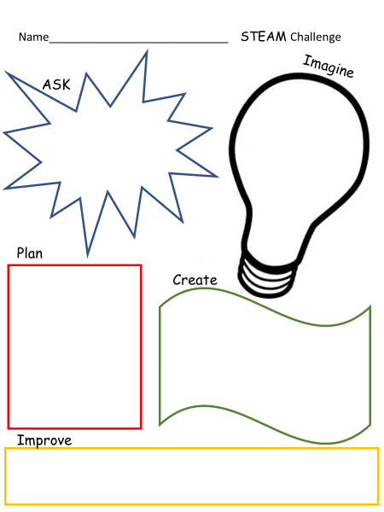

**RUBRIC**

|  |  |  |  |  |
| --- | --- | --- | --- | --- |
| A-Project is neat and on time using a variety of materials-Summary is answered in detail with complete sentences. Shows evidence of research. Each step of EDP is filled out completely. | B-Project is neat using many materials. Summary is answered with most details. Shows some evidence. Most of EDP chart is completed. | C-Project is completed. Summary has some details. EDP shows some planning. | D-Inconsistent evidence of understanding. Many parts are missing or late. | F- Project not turned in. |